• The majority of motor vehicle/cycle crashes

occur at urban intersections and driveways.

• Usable road shoulder width is a key factor

in the incidence of rural accidents.

• Heavy vehicles, especially trucks, are

overrepresented in cycling fatalities.

system and User Information: Improve quantity

and quality of data collection, research, sharing and

analysis. Use this information to set targets; and

strengthen processes for monitoring and evaluation.

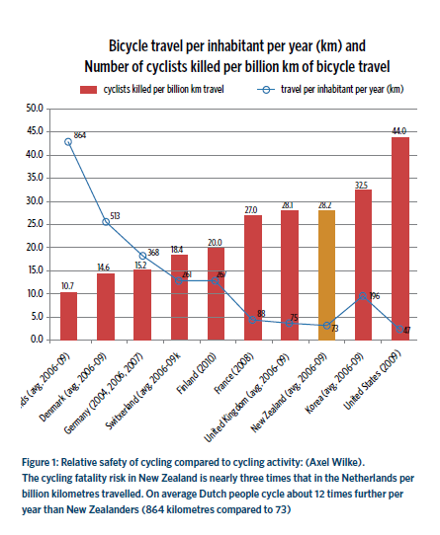

Cycling surveys consistently state the number one

reason people don’t cycle, or don’t let their children

cycle, is they believe it is too dangerous.

Mass protests continued to demand dedicated

cycling infrastructure. It is now an integral part of the

Netherlands’ transport policies. Child road deaths

have gone down to 14 in 2010 from over 400 in 1971

Land designated for new roads often does not

make allowance for safe cycling infrastructure.